**TECHNICAL REPORT**

**19910 Naios Anti-decubitus mattress system**

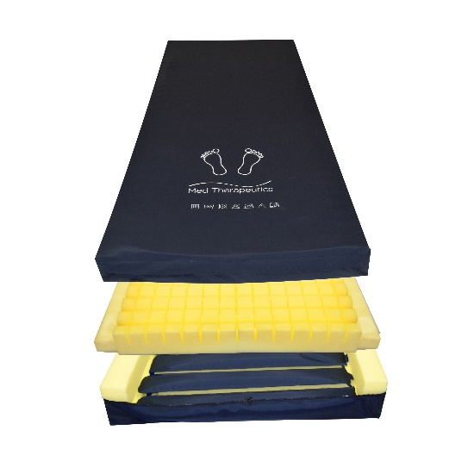 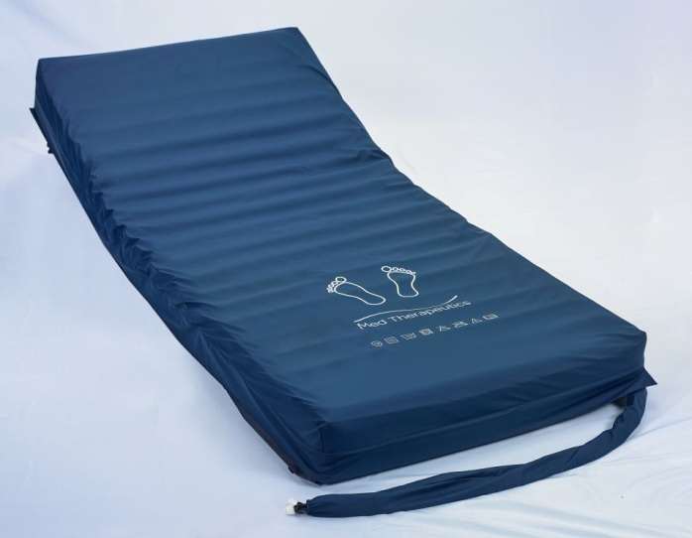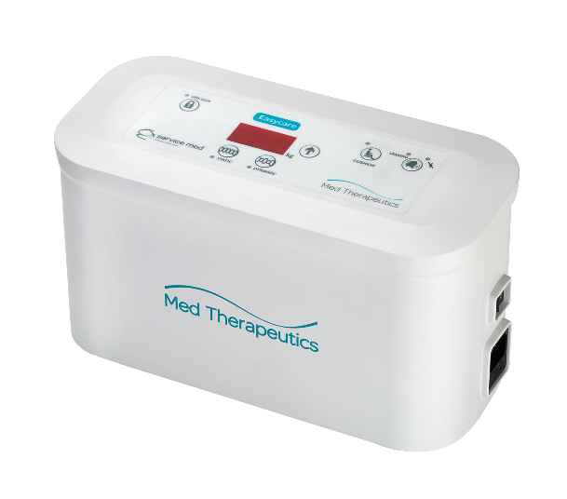

|  |  |
| --- | --- |
| **1. Product description** |  |
| **1.1. Intended use** . | **2** |
| **1.2. System description** ... | **2** |
| **1.2.1. Anti-decubitus surface** .... | **3** |
| **1.2.2. Cover** …….………………………..……….……………… | **3** |
| **1.2.3. Pump** ……………………………………………….…. | **3** |
| **2. Datasheet** …………………………………………………..………… | **5** |
| **2.1.Mattress specifications & 2.1.1 cover specification**............................ | **6** |
| **2.2 Pump specifications**.....................................................................6 |  |
| **2.3.Washing prescriptions and system sanification** ….... | **6** |

**2.4 CE Marking and EC directives**...................................................................6

# PRODUCT DESCRIPTION

## Intended use

19910 Naos is a Hybrid dynamic anti-decubitus mattress system using an air mattress made from nylon & polyeurathane and powered by an air pump to redistribute pressure across the surface of the mattress to avoid vascular compression particularly on areas of bony protrusion such as heels or the sacrum . It also acts as a hybrid non dynamic mattress when not used with a pump. It is a dynamic surface indicated for the prevention of decubitus ulcers up to stage IV and it is available for patients up to 250kg . The particular structure of the mattress, its modularity and flexibility make it adaptable to all kind of profiling beds in a domestic or hospital environment.

To use properly the mattress, we suggest to call on competent or paramedical/medical staff. According to D. Lgs. 81/2008, the surface can be managed in complete safety.

## System description

19910 Naos mattress system (Fig. 1) is composed by a dynamic anti-decubitus mattress with its cover and a pump that powers the mattress. The mattress can be positioned directly on the bed structure to replace the traditional mattress and it can also fit electrical adjustable bed movements. Thanks to the serigraphy printed on the cover, it is very easy to recognize the upper side of the mattress Naos and unlike traditional mattresses, Naos must not be periodically flipped. The Air pump Naos has an internal air compressor to deliver 10 litres of an air per minute through the two air ports on the side of the pump to inflate the mattress.

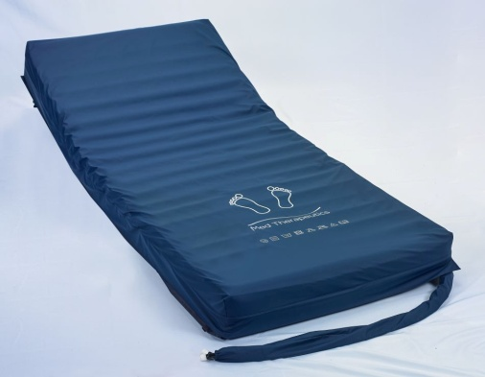 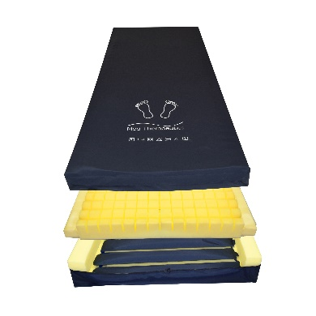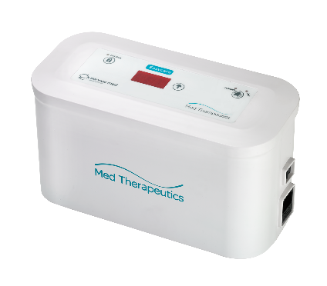

**Figure 1**. 19910 Naos

### Antidecubitus mattress

The Naos anti-decubitus mattress is made of five different layers that perfectly adapt to the body shapes and guarantee lower values of contact pressures while providing a high comfort level.

The first bottom layer is the mattress base made from Nylon and holds within its walls and base the second part of the mattress. The second part is a foam base with foam walls that house the third part of the mattress. The third layer of the mattress is a series of air cells and piping of up to 16 cells made from polyeurythene that alternately fill with air to provide support but then after 5 minutes empty out to give pressure relief whilst the cell next to it fills with air to give support. The first cell from the foot end of the mattress and each alternate cell are known as A cells and the cells inbetween are known as B cells with A & B cells alternately giving support or relief.The fourth layer or part of the mattress is a castellated foam topper that will shaped and adapt to the bed profile. This means should the mattress suddenly deflate due to power outage, mattress leak or disconecction from the pump the patient will sink down onto a foam mattress comprising a foam topper and a foam base. The matress is comprised in such a way that it can be used as a stand alone foam matress without need for a pump or power. Should the patients skin condition deteriate then the Naos pump can be connected and will inflate the 16 cells hidden between the foam base and the foam topper. The modular structure of the cells mean that the mattress profiles to most hospital & nursing beds. The fifth and last layer is the cover which has high stretch properties to help it conform to patient movements

The bearing structure is made of PU. All Polyurethane material used are Latex-free, Phthalate-free and fire retardant.

The system is totally radiotransparent.

### Cover

The upper cover is made of Polyester-Polyurethane .This particular material used is bi-elastic (with a low friction coefficient), waterproof and resistant to body fluids, vapour perspirant, fire resistant, smell and spot repellent, anti-bacterial, anti-fungal, antistatic, Latex-free and Phthalate-free.

The entire cover is easy to be removed from the mattress and it is interchangeable through a zip, which is properly covered by a flap; The cover is easily cleanable .Clinical tests on the upper cover confirm that the material doesn’t produce any kind of allergic reaction. Further details are reported in the data sheet section.

Tests also show that the cover is completely non-toxic for patient’s skin and oral tract.

**1.2.3 Pump**

The Nexus pump is a Medical Device Class 1 when used in conjuction with mattress Naos . It is a 220V-240V 50HZ mains powered pump using a quiet internal air compressor to alternatively deliver air to the mattress A cells and then by use of the internal rotor valve it will then 5 minutes later deliver air to mattress Naos B cells using the two A&B air ports on the side of the pump. Use of intelligent pressure sensing technology means that the pump switches off when the optimum internal pressure is reached. Weight of the patient is automatically sensed using two pressure sensors. This will ensure the correct and optimum internal pressure is achieved.

|  |  |
| --- | --- |
| **Power consumption** | 7W |
| **Fuse rating** | F2A 250VAC |
| **Electrical isolation** | Class I 2a |
| **Ingress protection** | IP21 |
| **IEC conformity** | 60601-1, 60601-1-2, 60601-11 |
| **Warranty** | 2 years against all manufacturing faults |

# DATASHEET

|  |  |
| --- | --- |
| **Manufacturer** | Sequoia Healthcare |
| **Production date** | 2021 |
| **Device** | Anti-decubitus dynamic mattress system |
| **Mattress Type** | Dymanic mattress system (powered) |
| **Classification, according to**  **93/42/CEE** | Medical device Class I |
| **Intended use** | Prevention of decubitus ulcers up to stage IV |
| **Conformity** | 93/42/CEE and subsequent modifications and additions  UNI EN ISO 13485 and UNI EN ISO 9001  Medical Devices Directive 2007/47/EC |
| **Warranty** | 1 years (for both the mattress, pump and the cover) |
|  |  |

## 2.1. Mattress specifications

|  |  |
| --- | --- |
| **System description** | Anti-decubitus dynamic mattress system (powered by its supporting air pump) mattress made from PU cells to support the patient and alternatively give support and pressure relief and encased in Nylon base & PU zipped cover  Latex and Phthalate free. Completely radiotransparent device. |
| **Foam description** | Foam base and foam walls are made from fire retardent foam . The foam topper is castellated to help shape to patient bodies whilst profiled on hospital beds. The topper is also fire retardent |
| **Mattress standard size** | 200 x 90 x 15 cm (non-standard size on request) |
| **Device’s weight** | 13 Kg |
| **Maximum supported weight** | 250 Kg |
| **Fire resistance** | Component materials (Polyurethane and the entire cover) are certified  by the manufacturer as fire resistant |

**2.2.1 Cover specifications**

|  |  |  |
| --- | --- | --- |
| **Composition** | Upper cover: Polyester-Polyurethane; it is antifungal, antibacterial, breathable to water steam, waterproof and resistant to liquids, smell and  spot repellent, fire resistant and machine washable. Latex and Phthalate free. | |
| **MECHANICAL AND PHYSICAL PROPERTIES OF UPPER COVER** | | **STANDARD** |
| **Waterproofness** | > 3000 mm | EN ISO 811 |
| **Breathability** | >= 600 g/m2 x 24 h at 38° | ASTM E96 |
| **Fire standard** | CRIB 5 | BS 6807- BS 7175 |
| **Notes** | * Permanent antimycotic and antibacterial barrier; moisture resistant * Resistant to all organic fluids * Washing prescriptions are printed on the cover | |

## 2.2. Pump specifications

|  |  |
| --- | --- |
| **Pump description** | Anti-decubitus dynamic pump. Connects to the mattress via quick release connectors . Two air ports alternatively deliver air to the A cells and then after 5 minutes the B cells through the two hoses at the foot end of the mattress  . |
| **Pump standard size** | 30cm x 12cm x 15 2.4kg |
| **Device’s weight** | 2.4KG |
| **Maximum supported weight** | 250kg |

**2.2.1 Cover specifications**

|  |  |  |
| --- | --- | --- |
| **Composition** | Upper cover: Polyester-Polyurethane; it is antifungal, antibacterial, breathable to water steam, waterproof and resistant to liquids, smell and  spot repellent, fire resistant and machine washable. Latex and Phthalate free. | |
| **MECHANICAL AND PHYSICAL PROPERTIES OF UPPER COVER** | | **STANDARD** |
| **Waterproofness** | > 3000 mm | EN ISO 811 |
| **Breathability** | >= 600 g/m2 x 24 h at 38° | ASTM E96 |
| **Fire standard** | CRIB 5 | BS 6807- BS 7175 |
| **Notes** | * Permanent antimycotic and antibacterial barrier; moisture resistant * Resistant to all organic fluids * Washing prescriptions are printed on the cover | |

* 1. **Washing prescriptions and system sanification (figure 1)**

|  |  |
| --- | --- |
| **Cover washing prescriptions** | * Machine washable up to 70°C**(*)** with a proper non aggressive cleaning agent * The normal cleaning instructions are to wipe the surface clean with a soft sponge or soft cloth with warm soapy water   The upper cover can tolerate Chlorine releasing agents at maximum 1,000 Parts Per Million (0.1% ppm); whenever Chlorine solution is used, the cover must be washed afterwards with water so the chlorine residue does not stay on it. However, please be aware that the stronger is Chlorine solution used (max 0.1% ppm) the higher rate of upper cover replacement  will be required in time. |
| **Disinfection** |  |

**(*)** A temperature of 60°C is suggested to perform an effective disinfection while better preserving the serigraphy and the material over time.

**2.3 Specifications**

|  |  |  |  |
| --- | --- | --- | --- |
| **Technical Specifications** | | **Atmospheric Specifications** | |
| **Therapy modes** | Dynamic & Static | **Storage temperature** | -25 - 70°C |
| **Compressor air flow** | Approx. 10lpm | **Transport temperature** | -25 - 70°C |
| **Cycle time** | 10 minutes | **Operating temperature** | 5 - 40°C |
| **Anti-particle filter** | Yes | **Humidity** | 10 - 90% |
| **Visual and audible alarms** | Yes | **Atmospheric pressure** | 700 - 1060hPa |
| **Electrical power supply** | | 220 – 240V / 50Hz | |
| **Power consumption** | | 7W (Airwave 1010: 8W) | |
| **Fuse rating** | | F2A 250VAC | |
| **Electrical isolation** | | Class I 2a | |
| **Ingress protection** | | IP21 | |
| **IEC conformity** | | 60601-1, 60601-1-2, 60601-11 | |
| **Warranty** | | 2 years against all manufacturing faults | |

|  |  |
| --- | --- |
| **CE marking** | |
| CE Marking indicating conformance to EC Directive No. 2007/47/EC concerning medical devices | |
| Type BF Applied Part (patient isolation from electrical shock) | |
| Class II Product  Indicates separate collection for electrical and electronic equipment (WEEE)  IP Protection rating: IP21 – protection against finger and dripping water | |
|  | |
|  | |
|  |  |
|  | |
|  | |